


THE WEEKLY WORD – April 1, 2026
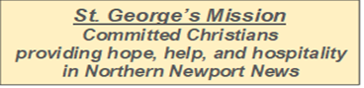
HOLY WEEK

Join us along with St. Mark’s at St. Augustine’s
Sunday April 5th at 10:30am
for Easter Sunday Holy Eucharist Rite II

YouTube channel
https://www.youtube.com/@St.AugustinesNNEpiscopalChurch
for those who cannot attend in person

Rev. Charlie updated the Senior Wardens: he is safely in California, though his brother is not doing well. He is minimally responsive and being treated for multiple respiratory ailments. Please keep Charlie, his brother Colman, his sister Sarah, and their families in prayer.

PMP and Friends
Holy Week and Easter Worship Schedule

Maundy Thursday Service – April 2, 2026
Potluck Agape Dinner to follow
5:30pm St. Mark’s Episcopal Church
Home of Andrew Marshall and Bert Pearce-Marshall
564 Leonard Lane, Newport News, VA 23601

Good Friday Services – April 3, 2026

12:00pm Stations of the cross at St. Andrew's Episcopal Church
12:00pm Stations of the cross at St. Stephens Episcopal Church

Stations of the Cross that were scheduled for noon at St. Augustine's have been cancelled.

6:30pm St. Andrew’s Episcopal Church
45 Main Street, Newport News, VA 23601
and
7:00pm St. Stephen’s Episcopal Church
372 Hiden Blvd, Newport News, VA 23606

Easter Morning Service – April 5, 2026
10:30am: St. Augustine’s Episcopal Church
2515 Marshall Ave, Newport News, VA 23607

Peninsula Ministry Partnership (St. Augustine’s, St. George’s, and St. Mark’s)
Sharing our Ministry Together
THANK YOU to all who made Palm Sunday possible at St. George's. The service was wonderful, as was the fellowship and the emerging friendships between our three respective congregations. The "endurance award" goes to Danny and Ann-Marie, who dialed in via phone and stayed for the entire service! – Andy Marshall, Sr. Warden St. Mark’s
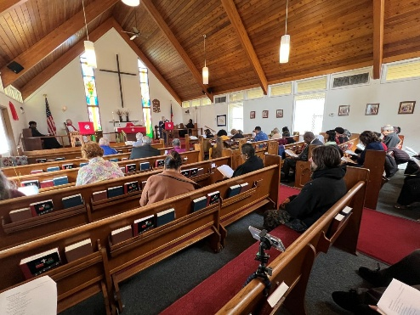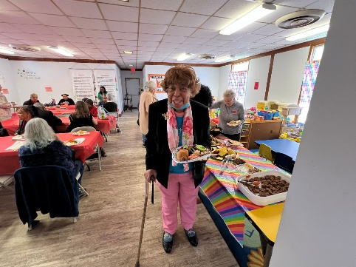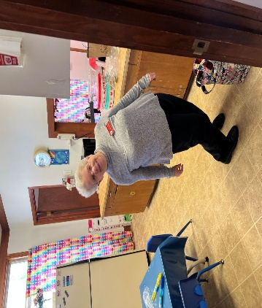
We also want to thank Rev Marc Vance from St. Andrews Episcopal Church for stepping in at the last minute to bless our three PMP churches with a beautiful Palm Sunday service.

Invitation to Compline with St. Mark’s
On Wednesday evenings at 7pm, St. Mark’s hosts a service of healing prayers, followed by either traditional Compline or New Zealand Night Prayers. This usually takes no more than 20 minutes.
They would love to have other members of the PMP join them. It's presently hosted on the St. Mark's Zoom channel (info is below, or click the Zoom icon at the bottom of www.smechampton.org).
Join Zoom Meeting
https://us02web.zoom.us/j/84430506697?pwd=bUluNDZES1JscHFTcjdaQlptL2FEdz09
Meeting ID: 844 3050 6697
Password: 5414
One tap mobile
+13017158592,,84430506697# US
Dial by your location
+1 301 715 8592 US
+1 253 215 8782 US
+1 267 831 0333 US
Meeting ID: 844 3050 6697

Episcopal 101: For the Curious and More!
Are you new to the Episcopal Church? Would you like to learn more about the church’s history, her customs and traditions, her theological understandings? Been around for a while and still curious about why we do this and that?
Never been Confirmed? Confirmed in another faith but ever been officially Received into the Episcopal tradition? Or maybe you might be interested in recommitting to your faith with an official Reaffirmation of your Baptismal Vows? Or maybe you’re just interested in brushing up on your Episcopal know-how.
Join Fr. Charlie for a journey into the heart of the “Anglican identity and ethos” as we explore the depths of our particular approach to the Christian faith. We’ll look into our history, our approach to theology and biblical interpretation, how we make decisions at local, regional and international levels, our experience over time with social justice movements, and our worship. Bring your questions, ideas, and “things that make you go hmmm.”
We will meet at a mutually convenient day and time starting in Lent for a short series of 90-minute sessions. Interested? Please email Fr. Charlie at c_de_kay@hotmail.com.

St. George’s News

PLUMBING NEWS

Gravely Hall Plumbing repairs will begin on March 30th and should be completed by April 2. If you have to go to Gravely Hall for any reason, please be aware that the main hallway near the bathrooms, the entrance into the kitchen from the hallway, and the pantry will most likely be blocked off and/or impassable during this time.
Thanks for your patience in this long and difficult journey through Gravely Hall piping woes.

Environmental Stewardship – by Lisa Adams
What are those strange boxes in the Narthex and Community Focus? These boxes are in support of a DIOSOVA Creation Care Team project that involves a partnership between the Creation Care Team, Church of the Ascension in Norfolk (who is hosting the collection), a company called Terra Cycle and hopefully the good stewards at St. George’s.
Terra Cycle Zero-Waste Boxes are used to collect hard-to-recycle items that would typically end up in landfills. The Creation Care Team has identified eleven categories of hard-to-recycle items that individuals or churches can collect. Those items include bottle caps (like the ones on the small water bottles we use), pens, pencils & markers, oral care waste & packaging, contact lenses & packaging, synthetic corks, water filters, coffee bags, beauty products & packaging, plastic straws, glue sticks & glue bottles and disposable cups & lids. See below for the one-page summary of the acceptable and unacceptable items.
There are 2 Terra Cycle boxes – one in the narthex and one in Community Focus - which have a comprehensive list of items attached to each box. There is also a box for regular recyclables such as the plastic water bottles from coffee hour, that would typically be recycled by Newport News. Please do NOT use these for trash!
I will take responsibility to take the items from these boxes to the appropriate drop off locations. Thanks for supporting this worthwhile effort to help save God’s amazing creation!

THE FOLLOWING ITEMS CAN BE RECYCLED

• BEAUTY PRODUCTS AND PACKAGING - Empty Cosmetic, Hair & Skin Care Packaging including Aluminized Tubes, Cosmetic Cases & Sticks, Plastic Packaging Unacceptable Items: Aerosol & Pressurized Cans, Cardboard, Electronic Items, Nail Polish Bottles & Removers, Partially Full & Full Packaging, Perfume Bottles, Wood & Bamboo, Wooden Eyeliner Pencils

• PENS, PENCILS & MARKERS - Pens, Pencils (non-wood), Highlighters, Markers & Caps, Mechanical Pencils, Pen & Pen Caps, Permanent Markers & Caps. Unacceptable Items: Paint Brushes, Wooden Pencils

• BOTTLE CAPS – Metal & Plastic Drink Bottle Caps Unacceptable Items: Bottles, Packaging, Liquids

• WATER FILTERS - Any Brand & Any Size Water Filters Unacceptable Items: Air Filters, Oil Filters

• CONTACT LENSES & PACKAGING - Contact Lenses, Plastic Film, Pods, And Cardboard Packaging Unacceptable Items: Contact Lens Solution, Bottles

• ORAL CARE WASTE & PACKAGING - Floss Containers, Toothbrush & Toothpaste Outer Packaging, Toothbrushes, Toothpaste Tubes & Caps Unacceptable Items: Floss, Other Oral Waste Care Items

• COFFEE BAGS – Empty Coffee Bags Unacceptable Items: Capsules, Coffee Grounds, Discs, Filters, Coffee Electronics, Other Coffee Packaging

• CORKS – Synthetic Beverage Corks Unacceptable Items: Natural Corks, Aluminum Champagne Twists, Bottle Caps, Bottles, Foil, Screw Tops

• STRAWS – Any Size Plastic Straws Unacceptable Items: Paper Straws, Biodegradable Straws

• DISPOSABLE CUPS & LIDS – Paper Coated Cups, Plastic Cups, Plastic Lids Disposable Cups & Lids that have been rinsed and dried Unacceptable Items: Biodegradable Plastic Cups & Lids, Juice Boxes & Pouches. Other Rigid Plastic Containers
• GLUE STICKS & BOTTLES – Empty Craft Glue Stick Containers & Empty Glue Bottles Unacceptable Items: Industrial Adhesive Containers 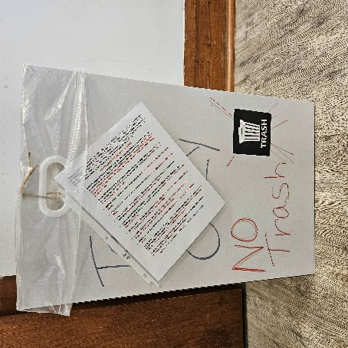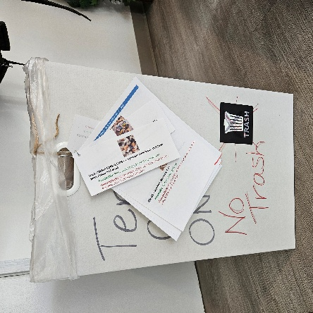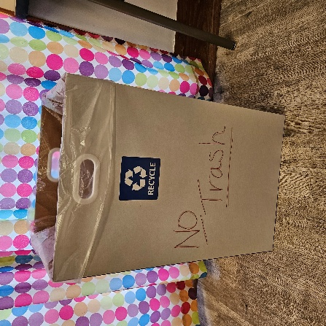

St. George’s Prayer List
Deania, Teresa & Steve S., Davidsinia, Christina M., Richard, Vincent, Linell, Henrietta, Lacy, Wil, David G., Peggy, Skip J., Darlene M., Gale, Sandra, Serena, Gerald, Joan M., Carmen, Jennifer H., Bobby, Gwen, Candace, Urith, Janette, Phyllis M., Calvin, Richard and Ronda T., Mary S., Pamela E., Bill B., Leslie T., Brian M., Connie, Billy, Celestina, Thelma, Aimee S., Mark, Yvette, and Connie H. And Our Military: Eduardo, Joe, Ashley, Charles, Anthony, Nyla, and Dominique.

Readings for April 5th Easter
There are alternate readings for Easter Morning so both are below

Acts 10:34-43
Peter began to speak to Cornelius and the other Gentiles: "I truly understand that God shows no partiality, but in every nation anyone who fears him and does what is right is acceptable to him. You know the message he sent to the people of Israel, preaching peace by Jesus Christ--he is Lord of all. That message spread throughout Judea, beginning in Galilee after the baptism that John announced: how God anointed Jesus of Nazareth with the Holy Spirit and with power; how he went about doing good and healing all who were oppressed by the devil, for God was with him. We are witnesses to all that he did both in Judea and in Jerusalem. They put him to death by hanging him on a tree; but God raised him on the third day and allowed him to appear, not to all the people but to us who were chosen by God as witnesses, and who ate and drank with him after he rose from the dead. He commanded us to preach to the people and to testify that he is the one ordained by God as judge of the living and the dead. All the prophets testify about him that everyone who believes in him receives forgiveness of sins through his name."
or

Jeremiah 31:1-6
At that time, says the Lord, I will be the God of all the families of Israel, and they shall be my people.
Thus says the Lord:
The people who survived the sword
found grace in the wilderness;
when Israel sought for rest,
the Lord appeared to him from far away.
I have loved you with an everlasting love;
therefore I have continued my faithfulness to you.
Again I will build you, and you shall be built,
O virgin Israel!
Again you shall take your tambourines,
and go forth in the dance of the merrymakers.
Again you shall plant vineyards
on the mountains of Samaria;
the planters shall plant,
and shall enjoy the fruit.
For there shall be a day when sentinels will call
in the hill country of Ephraim:
“Come, let us go up to Zion,
to the Lord our God.”

The Psalm

Psalm 118:1-2, 14-24
Confitemini Domino
1 Give thanks to the Lord, for he is good; *
his mercy endures for ever.
2 Let Israel now proclaim, *
"His mercy endures for ever."
14 The Lord is my strength and my song, *
and he has become my salvation.
15 There is a sound of exultation and victory *
in the tents of the righteous:
16 "The right hand of the Lord has triumphed! *
the right hand of the Lord is exalted!
the right hand of the Lord has triumphed!"
17 I shall not die, but live, *
and declare the works of the Lord.
18 The Lord has punished me sorely, *
but he did not hand me over to death.
19 Open for me the gates of righteousness; *
I will enter them;
I will offer thanks to the Lord.
20 "This is the gate of the Lord; *
he who is righteous may enter."
21 I will give thanks to you, for you answered me *
and have become my salvation.
22 The same stone which the builders rejected *
has become the chief cornerstone.
23 This is the Lord's doing, *
and it is marvelous in our eyes.
24 On this day the Lord has acted; *
we will rejoice and be glad in it.

The Epistle

Colossians 3:1-4
If you have been raised with Christ, seek the things that are above, where Christ is, seated at the right hand of God. Set your minds on things that are above, not on things that are on earth, for you have died, and your life is hidden with Christ in God. When Christ who is your life is revealed, then you also will be revealed with him in glory.
or

Acts 10:34-43
(See above.)

The Gospel

John 20:1-18
Early on the first day of the week, while it was still dark, Mary Magdalene came to the tomb and saw that the stone had been removed from the tomb. So she ran and went to Simon Peter and the other disciple, the one whom Jesus loved, and said to them, “They have taken the Lord out of the tomb, and we do not know where they have laid him.” Then Peter and the other disciple set out and went toward the tomb. The two were running together, but the other disciple outran Peter and reached the tomb first. He bent down to look in and saw the linen wrappings lying there, but he did not go in. Then Simon Peter came, following him, and went into the tomb. He saw the linen wrappings lying there, and the cloth that had been on Jesus’ head, not lying with the linen wrappings but rolled up in a place by itself. Then the other disciple, who reached the tomb first, also went in, and he saw and believed; for as yet they did not understand the scripture, that he must rise from the dead. Then the disciples returned to their homes.
But Mary stood weeping outside the tomb. As she wept, she bent over to look into the tomb; and she saw two angels in white, sitting where the body of Jesus had been lying, one at the head and the other at the feet. They said to her, “Woman, why are you weeping?” She said to them, “They have taken away my Lord, and I do not know where they have laid him.” When she had said this, she turned around and saw Jesus standing there, but she did not know that it was Jesus. Jesus said to her, “Woman, why are you weeping? Whom are you looking for?” Supposing him to be the gardener, she said to him, “Sir, if you have carried him away, tell me where you have laid him, and I will take him away.” Jesus said to her, “Mary!” She turned and said to him in Hebrew, “Rabbouni!” (which means Teacher). Jesus said to her, “Do not hold on to me, because I have not yet ascended to the Father. But go to my brothers and say to them, ‘I am ascending to my Father and your Father, to my God and your God.’” Mary Magdalene went and announced to the disciples, “I have seen the Lord”; and she told them that he had said these things to her.
or

Matthew 28:1-10
After the sabbath, as the first day of the week was dawning, Mary Magdalene and the other Mary went to see the tomb. And suddenly there was a great earthquake; for an angel of the Lord, descending from heaven, came and rolled back the stone and sat on it. His appearance was like lightning, and his clothing white as snow. For fear of him the guards shook and became like dead men. But the angel said to the women, “Do not be afraid; I know that you are looking for Jesus who was crucified. He is not here; for he has been raised, as he said. Come, see the place where he lay. Then go quickly and tell his disciples, ‘He has been raised from the dead, and indeed he is going ahead of you to Galilee; there you will see him.’ This is my message for you.” So they left the tomb quickly with fear and great joy, and ran to tell his disciples. Suddenly Jesus met them and said, “Greetings!” And they came to him, took hold of his feet, and worshiped him. Then Jesus said to them, “Do not be afraid; go and tell my brothers to go to Galilee; there they will see me.”

