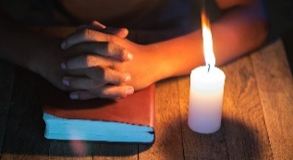

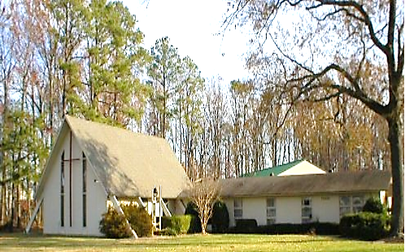
THE WEEKLY WORD – March 11, 2026
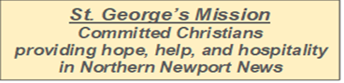
THIRD WEEK OF LENT

Join us at St. George’s on Sunday March 15th at 10:30am
for Morning Prayer

Servers for Sun. Mar 15th Open: Lisa Adams
AV/Sound: Laura Stepp Coffee Hour: Lee Vick
Greeter & Usher: Gerry Belden Lector 1: Bonnie Dodson
Lector 2: Lisa Adams Close: Gerry Belden

ZOOM LINK FOR 10:30 am SERVICE

https://zoom.us/j/117414681?pwd=Mk1Da29jRk9Wb3V2N1hEY2V6M1l3dz09

Meeting ID: 117 414 681 - Password: 016023

An important announcement
for all who join us for Sunday Worship on Zoom: During the service, remember to:

mute your home microphone - it will look like this

and
turn off your computer camera - it will look like this
If left on, your image appears & comments heard and that’s a distraction. Thank you!

Beating the Bounds – a Thanksgiving Journey
By Lisa Adams
On Sunday, March 8, St. George’s parishioners took part in an old Anglican tradition known as Beating the Bounds. The practice has deep roots in the life of the Church and offers a meaningful way to remember our connection to place, community, and God’s provision.
Historically, Beating the Bounds took place during Rogationtide—the days leading up to the feast of the Ascension. Members of the parish would walk the edges of their parish lands. Along the way they would stop to pray for God’s blessing on the fields, the crops, and the people who lived and worked there. At key points marking the boundary, the group would tap or “beat” the landmark with sticks, ensuring that everyone, remembered exactly where the parish limits lay.
This annual procession served several purposes. It reinforced a shared understanding of the parish’s geography, helped prevent disputes over land, and most importantly, invited God’s blessing upon the community and the land that sustained it. The prayers of Rogationtide asked for fruitful harvests, protection from disaster, and God’s continued care for the people.
For our congregation, this practice also carried an added note of thanksgiving. As we reflected on the land entrusted to the Church, we gave thanks for the recent sale of the unused portion of our church property and for the many people whose work, wisdom, and faithfulness helped bring that process to completion. We are grateful for God’s guidance throughout the journey and for the ways these resources will now support the ongoing mission and ministry of our parish.
Whether done formally or simply remembered in prayer, Beating the Bounds reminds us that our parish is not just a building or a piece of land. It is a people called by God and planted in a particular place. As we pray for the neighborhoods around us, we renew our calling to serve, bless, and share Christ’s love with all who live within our “bounds
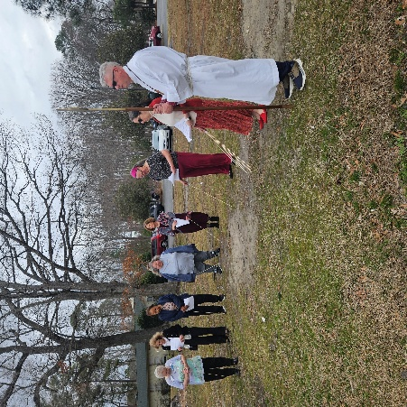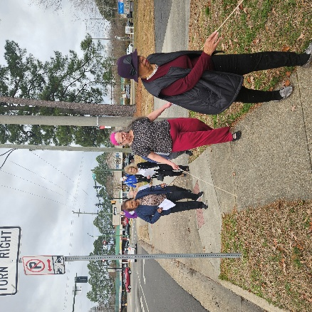
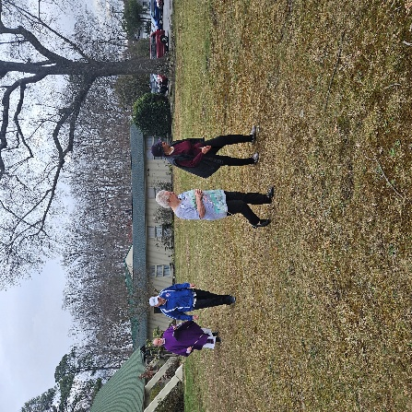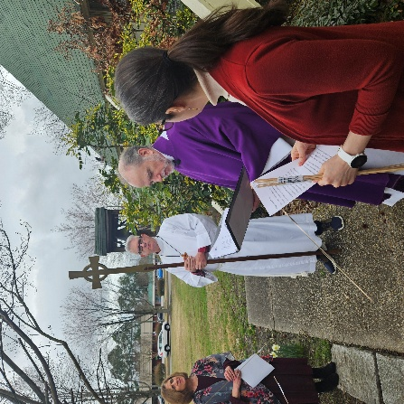

Peninsula Ministry Partnership (St. Augustine’s, St. George’s, and St. Mark’s)
Sharing our Ministry Together

St. Photini, the Samaritan Woman at the Well
Last Sunday Father Charlie was at St. George’s, his sermon of the day referenced St. Photini, the Samaritan Woman at the Well from John's Gospel, below is a link that has a brief illustrated biography from the Orthodox Church that Father Charlie thought everyone may find interesting

St Photini, The Samaritan Woman – Patron Saint of OCL – Orthodox Christian Laity

Invitation to St. Mark's Monthly Fellowship Event

St. Mark's will be meeting at 1st United Church of Christ, Hampton at 6PM on Friday, March 13th for their monthly fellowship event. They will have their usual potluck meal and a program about the symbols of Easter. They want the PMP family to know that we are always welcome to come and enjoy the meal and fellowship.
Invitation to Compline with St. Mark’s
On Wednesday evenings at 7pm, St. Mark’s hosts a service of healing prayers, followed by either traditional Compline or New Zealand Night Prayers. This usually takes no more than 20 minutes.
They would love to have other members of the PMP join them. It's presently hosted on the St. Mark's Zoom channel (info is below, or click the Zoom icon at the bottom of www.smechampton.org).
Join Zoom Meeting
https://us02web.zoom.us/j/84430506697?pwd=bUluNDZES1JscHFTcjdaQlptL2FEdz09
Meeting ID: 844 3050 6697
Password: 5414
One tap mobile
+13017158592,,84430506697# US
Dial by your location
+1 301 715 8592 US
+1 253 215 8782 US
+1 267 831 0333 US
Meeting ID: 844 3050 6697

Thursdays Lenten Bible Study With PMP
Held 7-8 pm; new attendees welcome! Father Charlie will be leading the new Lenten study starting this Thursday the 19th and continuing through the Lenten Season with the last study on Thursday March 26th Join the Zoom:
https://us06web.zoom.us/j/86815581353?pwd=GbbfcSIfFqDFISKrRGDM4ADwmuIG2G.1
Meeting ID: 868 1558 1353 Passcode: Lent2026

peninsula ministries partnership
2026 midweek lenten program
thursday nights, February 19 – march 26, 7-8pm
Every year on Ash Wednesday, the start of the season of Lent, the priest calls the church to the observance of a Holy Lent (The Book of Common Prayer, page 265).
The priest reminds the gathered community of the ancient Lenten tradition of the Church: It has long been a penitential time of preparation for the days of great devotion of Holy Week and Easter, featuring periods of fasting. It has also been a time set aside for the preparation for converts for Baptism (or catechesis), and likewise of reconciliation and restoration to the Body of Christ for those who had been excommunicated. All of this serves to remind the members of the Church of the essential call for all Christians “to renew their repentance and faith.”
Then, the priest says: “I invite you, therefore, in the name of the Church, to the observance of a holy Lent, by self-examination and repentance; by prayer, fasting, and self-denial; and by reading and meditating on God’s holy Word.”
In this ancient wisdom tradition, there are profound spiritual truths. The spiritual practices laid out in this one sentence provide a path to meet God. In the last century, the Church would have put it, that sincerely approached, this was the means to return to a “state of Grace.”
However we talk about it, this is part of The Way, in imitation of Christ, we experience God These practices have led to life-changing, transformative spiritual experiences.
Many of us have experiences with these practices – both positive and negative. I’d like to invite everyone who’s interested in sharing their experiences, or in learning more, to join us for an hour on Zoom Thursday nights in Lent. Who knows, you might hear something that you’ll want to try practicing this Lent, and that could lead to something important.We will open and close with prayer, and I’ll open the night’s discussion with a short introduction to topic, and the bulk of our time together will be in open conversation. Questions are always encouraged.

PMP and Friends
Holy Week and Easter Worship Schedule

Palm Sunday Service – March 29, 2026
10:30am St. George’s Episcopal Church
15446 Warwick Blvd, Newport News, VA 2308

Maundy Thursday Service – April 2, 2026
Potluck Agape Dinner to follow
5:30pm St. Mark’s Episcopal Church
Home of Andrew Marshall and Bert Pearce-Marshall
564 Leonard Lane, Newport News, VA 23601
(
Good Friday Services – April 3, 2026
Noon: Stations of the Cross
St. Augustine’s Episcopal Church
2515 Marshall Ave, Newport News, VA 23607

6:30pm Good Friday Liturgy
St. Andrew’s Episcopal Church
45 Main Street, Newport News, VA 23601
and
7:00pm St. Stephen’s Episcopal Church
372 Hiden Blvd, Newport News, VA 23606

Easter Morning Service – April 5, 2026
10:30am: St. Augustine’s Episcopal Church
2515 Marshall Ave, Newport News, VA 23607

UPCOMING EVENTS AT CAMP CHANCO

CHANCO AMBASSADORS MARCH REMINDERS

Spring Open House Sunday, March 15th 1– 4 PM
Discover the magic of Summer Camp at Chanco’s Spring Open House. There’s no better way to experience the spirit of Chanco than spending a fun-filled afternoon on the campgrounds where unforgettable memories are made, confidence is built, and lifelong friendships begin. Activities include hayrides, zip lining, face painting, guided tours, archery, and lunch.
To learn more, visit https://chanco.org/event/spring-open-house-2/

5K Adventure Race7, Saturday, March 21 Packet Pick-Ups & Registration 7:30-8:30 AM, Race Start at 9:00 AM
Run, hike or walk! This challenging trail course winds through scenic woods and along the shoreline of the James River. Whether you're chasing a personal record or taking in the scenery, the race promises to deliver fresh air, beautiful river views, and a challenge worth the effort. To learn more & register, visit https://chanco.org/event/chancos-5k-adventure-run/

Episcopal 101: For the Curious and More!
Are you new to the Episcopal Church? Would you like to learn more about the church’s history, her customs and traditions, her theological understandings? Been around for a while and still curious about why we do this and that?
Never been Confirmed? Confirmed in another faith but ever been officially Received into the Episcopal tradition? Or maybe you might be interested in recommitting to your faith with an official Reaffirmation of your Baptismal Vows? Or maybe you’re just interested in brushing up on your Episcopal know-how.
Join Fr. Charlie for a journey into the heart of the “Anglican identity and ethos” as we explore the depths of our particular approach to the Christian faith. We’ll look into our history, our approach to theology and biblical interpretation, how we make decisions at local, regional and international levels, our experience over time with social justice movements, and our worship. Bring your questions, ideas, and “things that make you go hmmm.”
We will meet at a mutually convenient day and time starting in Lent for a short series of 90-minute sessions. Interested? Please email Fr. Charlie at c_de_kay@hotmail.com.

Sunday Holy Eucharist

On Facebook and Zoom at 10:30 am

Face Book LIVE:

You don’t need an account! Just go to St. George’s web page: http://www.stgeorgesnn.org

You can access FaceBook Live during the Service time and any time after it takes place-it’s recorded.

St. George’s Prayer List
Deania, Teresa & Steve S., Davidsinia, Christina M., Richard, Vincent, Linell, Henrietta, Lacy, Wil, David G., Peggy, Skip J., Darlene M., Gale, Sandra, Serena, Gerald, Joan M., Carmen, Jennifer H., Bobby, Gwen, Candace, Urith, Janette, Phyllis M., Calvin, Richard and Ronda T., Mary S., Pamela E., Bill B., Leslie T., Brian M., Connie, Billy, Celestina, Thelma, Aimee S., Mark, Yvette, and Connie H. And Our Military: Eduardo, Joe, Ashley, Charles, Anthony, Nyla, and Dominique.

Readings for Mar 15th

1 Samuel 16:1-13
The Lord said to Samuel, “How long will you grieve over Saul? I have rejected him from being king over Israel. Fill your horn with oil and set out; I will send you to Jesse the Bethlehemite, for I have provided for myself a king among his sons.” Samuel said, “How can I go? If Saul hears of it, he will kill me.” And the Lord said, “Take a heifer with you, and say, ‘I have come to sacrifice to the Lord.’ Invite Jesse to the sacrifice, and I will show you what you shall do; and you shall anoint for me the one whom I name to you.” Samuel did what the Lord commanded, and came to Bethlehem. The elders of the city came to meet him trembling, and said, “Do you come peaceably?” He said, “Peaceably; I have come to sacrifice to the Lord; sanctify yourselves and come with me to the sacrifice.” And he sanctified Jesse and his sons and invited them to the sacrifice.
When they came, he looked on Eliab and thought, “Surely the Lord’s anointed is now before the Lord.” But the Lord said to Samuel, “Do not look on his appearance or on the height of his stature, because I have rejected him; for the Lord does not see as mortals see; they look on the outward appearance, but the Lord looks on the heart.” Then Jesse called Abinadab, and made him pass before Samuel. He said, “Neither has the Lord chosen this one.” Then Jesse made Shammah pass by. And he said, “Neither has the Lord chosen this one.” Jesse made seven of his sons pass before Samuel, and Samuel said to Jesse, “The Lord has not chosen any of these.” Samuel said to Jesse, “Are all your sons here?” And he said, “There remains yet the youngest, but he is keeping the sheep.” And Samuel said to Jesse, “Send and bring him; for we will not sit down until he comes here.” He sent and brought him in. Now he was ruddy, and had beautiful eyes, and was handsome. The Lord said, “Rise and anoint him; for this is the one.” Then Samuel took the horn of oil, and anointed him in the presence of his brothers; and the spirit of the Lord came mightily upon David from that day forward. Samuel then set out and went to Ramah.

The Psalm

Psalm 23
Dominus regit me
1 The Lord is my shepherd; *
I shall not be in want.
2 He makes me lie down in green pastures *
and leads me beside still waters.
3 He revives my soul *
and guides me along right pathways for his Name's sake.
4 Though I walk through the valley of the shadow of death,
I shall fear no evil; *
for you are with me;
your rod and your staff, they comfort me.
5 You spread a table before me in the presence of those who trouble me; *
you have anointed my head with oil,
and my cup is running over.
6 Surely your goodness and mercy shall follow me all the days of my life, *
and I will dwell in the house of the Lord for ever.

The Epistle

Ephesians 5:8-14
Once you were darkness, but now in the Lord you are light. Live as children of light— for the fruit of the light is found in all that is good and right and true. Try to find out what is pleasing to the Lord. Take no part in the unfruitful works of darkness, but instead expose them. For it is shameful even to mention what such people do secretly; but everything exposed by the light becomes visible, for everything that becomes visible is light. Therefore it says,
“Sleeper, awake!
Rise from the dead,
and Christ will shine on you.”

The Gospel

John 9:1-41
As Jesus walked along, he saw a man blind from birth. His disciples asked him, “Rabbi, who sinned, this man or his parents, that he was born blind?” Jesus answered, “Neither this man nor his parents sinned; he was born blind so that God’s works might be revealed in him. We must work the works of him who sent me while it is day; night is coming when no one can work. As long as I am in the world, I am the light of the world.” When he had said this, he spat on the ground and made mud with the saliva and spread the mud on the man’s eyes, saying to him, “Go, wash in the pool of Siloam” (which means Sent). Then he went and washed and came back able to see. The neighbors and those who had seen him before as a beggar began to ask, “Is this not the man who used to sit and beg?” Some were saying, “It is he.” Others were saying, “No, but it is someone like him.” He kept saying, “I am the man.” But they kept asking him, “Then how were your eyes opened?” He answered, “The man called Jesus made mud, spread it on my eyes, and said to me, ‘Go to Siloam and wash.’ Then I went and washed and received my sight.” They said to him, “Where is he?” He said, “I do not know.”
They brought to the Pharisees the man who had formerly been blind. Now it was a sabbath day when Jesus made the mud and opened his eyes. Then the Pharisees also began to ask him how he had received his sight. He said to them, “He put mud on my eyes. Then I washed, and now I see.” Some of the Pharisees said, “This man is not from God, for he does not observe the sabbath.” But others said, “How can a man who is a sinner perform such signs?” And they were divided. So they said again to the blind man, “What do you say about him? It was your eyes he opened.” He said, “He is a prophet.”
The Jews did not believe that he had been blind and had received his sight until they called the parents of the man who had received his sight and asked them, “Is this your son, who you say was born blind? How then does he now see?” His parents answered, “We know that this is our son, and that he was born blind; but we do not know how it is that now he sees, nor do we know who opened his eyes. Ask him; he is of age. He will speak for himself.” His parents said this because they were afraid of the Jews; for the Jews had already agreed that anyone who confessed Jesus to be the Messiah would be put out of the synagogue. Therefore his parents said, “He is of age; ask him.”
So for the second time they called the man who had been blind, and they said to him, “Give glory to God! We know that this man is a sinner.” He answered, “I do not know whether he is a sinner. One thing I do know, that though I was blind, now I see.” They said to him, “What did he do to you? How did he open your eyes?” He answered them, “I have told you already, and you would not listen. Why do you want to hear it again? Do you also want to become his disciples?” Then they reviled him, saying, “You are his disciple, but we are disciples of Moses. We know that God has spoken to Moses, but as for this man, we do not know where he comes from.” The man answered, “Here is an astonishing thing! You do not know where he comes from, and yet he opened my eyes. We know that God does not listen to sinners, but he does listen to one who worships him and obeys his will. Never since the world began has it been heard that anyone opened the eyes of a person born blind. If this man were not from God, he could do nothing.” They answered him, “You were born entirely in sins, and are you trying to teach us?” And they drove him out.
Jesus heard that they had driven him out, and when he found him, he said, “Do you believe in the Son of Man?” He answered, “And who is he, sir? Tell me, so that I may believe in him.” Jesus said to him, “You have seen him, and the one speaking with you is he.” He said, “Lord, I believe.” And he worshiped him. Jesus said, “I came into this world for judgment so that those who do not see may see, and those who do see may become blind.” Some of the Pharisees near him heard this and said to him, “Surely we are not blind, are we?” Jesus said to them, “If you were blind, you would not have sin. But now that you say, ‘We see,’ your sin remains.”

